**ASSIGNMENT: - 03**

# **Problem Statement: -**

Apply appropriate ML algorithm on a dataset collected in a cosmetics shop showing details of customers to predict customer response for special offers.

# **S/W, Library, Package: -**

1. **Software**: You can use either R or Python for this task. Both languages offer a range of libraries and tools for machine learning tasks.
2. **Library and Package**:

**Python**:

* 1. **Library**: scikit-learn (sklearn)
  2. **Packages**:
     1. pandas: For data manipulation and preprocessing.
     2. numpy: For numerical computations and array operations.
     3. matplotlib/seaborn: For data visualization.
     4. sklearn: For machine learning algorithms and model evaluation.

# **Theory:**

**Methodology**:

* R follows a functional programming paradigm with a focus on statistical computing and data analysis.
* It provides a vast collection of packages and libraries for various statistical techniques, data manipulation, and visualization.
* R uses a syntax that is concise and expressive, making it suitable for data-centric tasks.

**Advantages**:

1. **Statistical Analysis**: R offers a comprehensive set of statistical functions and algorithms for data analysis, hypothesis testing, regression, clustering, and more.
2. **Graphics and Visualization**: R has powerful graphics capabilities with packages like ggplot2 for creating high-quality plots, charts, and visualizations.
3. **Community and Packages**: The R community is large and active, contributing thousands of packages to CRAN, providing solutions for diverse analytical tasks.
4. **Integration and Reproducibility**: R integrates well with other languages and tools, and tools like RMarkdown support reproducible research by combining code, visualizations, and narrative text in interactive documents.

**Applications**:

* **Data Analysis**: R is widely used for data analysis in various domains such as finance, healthcare, marketing, and academia.
* **Statistical Modeling**: R is used for statistical modeling tasks like linear regression, logistic regression, time series analysis, and machine learning.
* **Data Visualization**: R is popular for creating visualizations ranging from simple plots to complex interactive dashboards.
* **Research and Academia**: R is extensively used in research, academic studies, and data-driven scientific research.

**Limitations**:

1. **Learning Curve**: R has a steep learning curve for beginners, especially those without a programming or statistical background.
2. **Performance**: Certain operations in R can be slower compared to other languages like Python, especially for large datasets or computationally intensive tasks.
3. **Production Deployment**: While R is excellent for prototyping and analysis, it may not be the best choice for large-scale production systems.

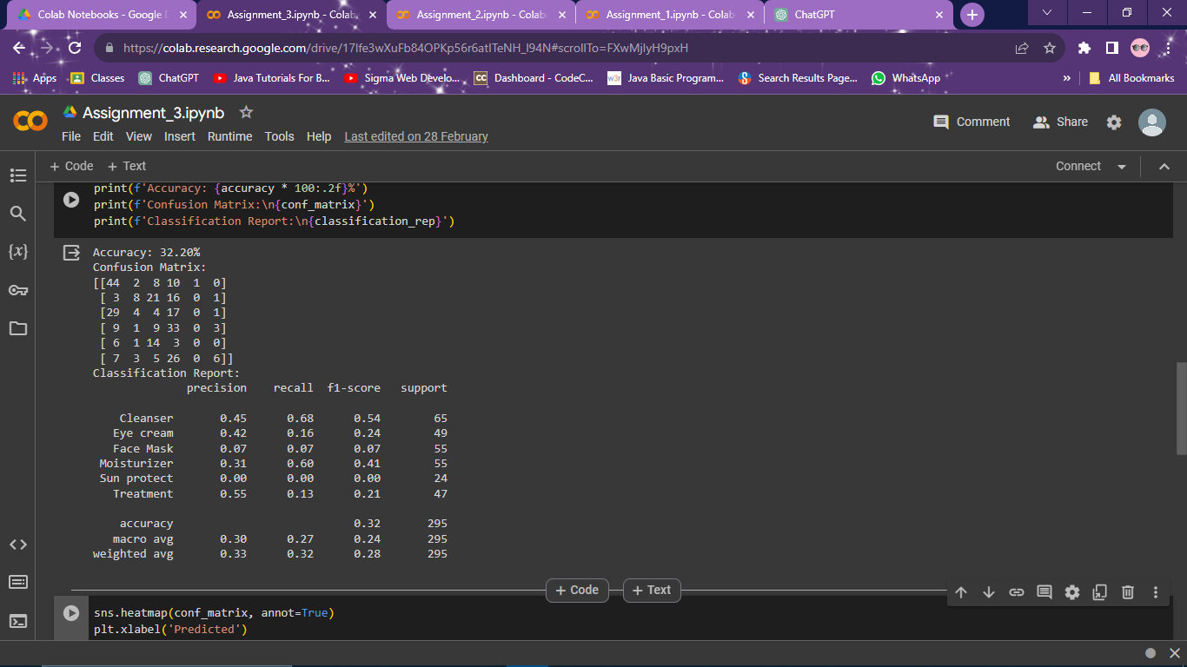 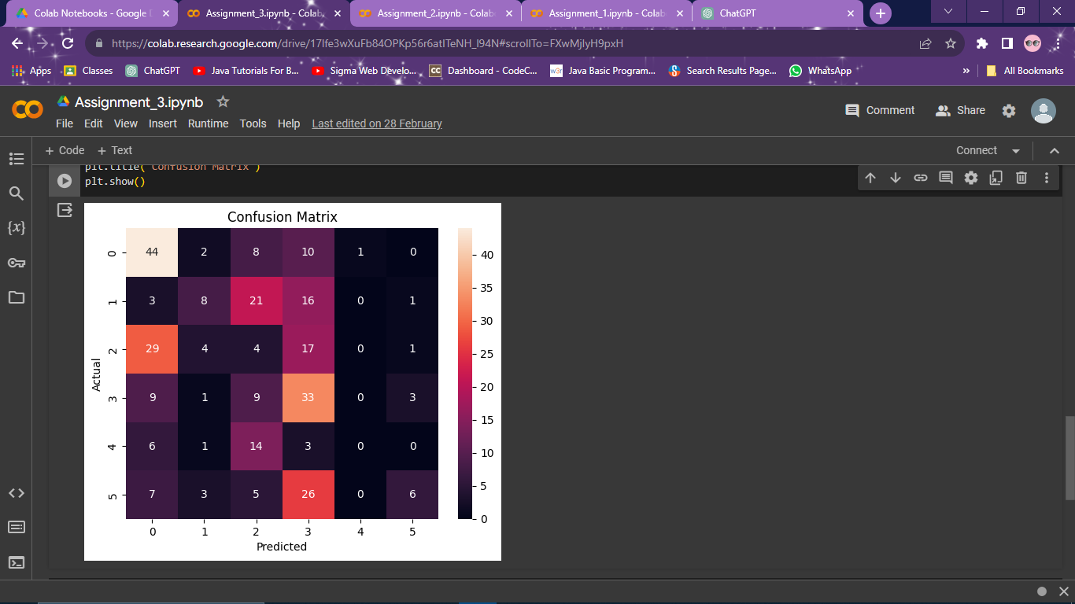

# **Conclusion:**

Applying a machine learning algorithm on a dataset from cosmetics shop to predict customer responses for special offers involves steps like data preprocessing, feature selection, model selection, training, evaluation, and prediction. A suitable algorithm such as logistic regression, decision trees, or random forest can be chosen based on the dataset characteristics. The model's performance is evaluated using metrics like accuracy, precision, recall, or F1-score. In conclusion, the ML algorithm helps in predicting customer responses effectively, aiding in targeted marketing strategies and offer optimizations.